University & library hub software

Team Members:
Ghaida Mesfer Asiri
Mather Shaher Al-Lihyani

1. Functional Requirements
• FR-1: Web-based unified portal for all user roles (Student, Instructor, Head of Department, Librarian).
• FR-2: Secure user authentication and role-based access using Authentication and UserAccount.
• FR-3: User account management (create, update, delete accounts, assign roles, manage profiles).
• FR-4: Department management (create, update, delete departments, assign Heads of Department).
• FR-5: Course management (create, update, delete courses, assign instructors and students).
• FR-6: Book management (add, update, delete books, search, check availability).
• FR-7: Borrowing management (submit borrow requests, return books, view history).
• FR-8: Academic request handling (submit and approve/reject course-related requests).
• FR-9: Grade management (assign/update grades, view grades).
• FR-10: Activity Logging The system shall log important operations.

2.Components and Component Diagram

Component | Type | Discretion | Related Database
University | Interface | Provides a unified web-based portal for all users (students, instructors, department heads, librarians) to access academic and library services. | —
API Gateway | Service | Centralizes incoming requests and routes them to the appropriate backend components. | —
Authentication | Service | Manages secure user authentication (login/logout) and enforces role-based access control. | UserAccountDB
UserAccount | Service | Manages user accounts (create, update, delete), roles (Student, Instructor, Head of Department, Librarian), and profile information. | UserAccountDB, ObjectDB
BorrowManagement | Service | Manages the borrowing process for library books.  Students and instructors use this component to create borrow requests, view their borrowed books, return books, and view their borrowing history, while the component updates the loan records and book availability in the library database. | LibraryDB
BookManagement | Service | Manages the library book catalog and access to book information.  Librarians can add, update, and delete books and check availability.  Students, instructors, and librarians can search for books and view book details. | LibraryDB
CourseManagement | Service | Manages the course catalog and provides course-related access to system users.  Course creation, update, and deletion are triggered by the Blackboard component through the Watcher. Students and instructors can view assigned courses, view department courses, and access detailed course information. | UniversityDB, GradeDB
Department | Service | Manages departments  Department creation, update, and deletion are triggered by the Blackboard component through the Watcher.  The Head of Department is responsible for assigning instructors to courses, assigning a head to each department, and assigning courses to students | UniversityDB
Grade | Service | Instructors can assign and update grades for students, while students can only view their grades | GradeDB
Request | Service | Handles academic requests such as course registration. Requests are submitted by students, processed through a Queue, and reviewed by the Head of Department for approval or rejection. | RequestDB
Blackboard | Service | Monitors changes in UniversityDB (using Watcher) and automatically scans and updates data. | UniversityDB
RequestRecorder | Middleware / Logging | Monitors and logs important operations like account changes, course updates, borrowing requests for auditing and debugging. | RecordActivityDB
RecordActivityDB | Database(SQL) | Stores logs of important system operations for auditing, monitoring, and troubleshooting. | —
RequestDB | Database(SQL) | Stores academic and administrative requests and their statuses. | —
GradeDB | Database(SQL) | Stores student grades for courses. | —
LibraryDB | Database(SQL) | Stores the library’s book catalog and borrowing records. | —
UniversityDB | Database(SQL) | Stores university-related data such as departments, courses. | —
ObjectDB | Database(NoSQL) | Stores binary data such as user profile images. | —

Component Diagram
Figure 1Below is the component diagram representing the key software components and their interactions.
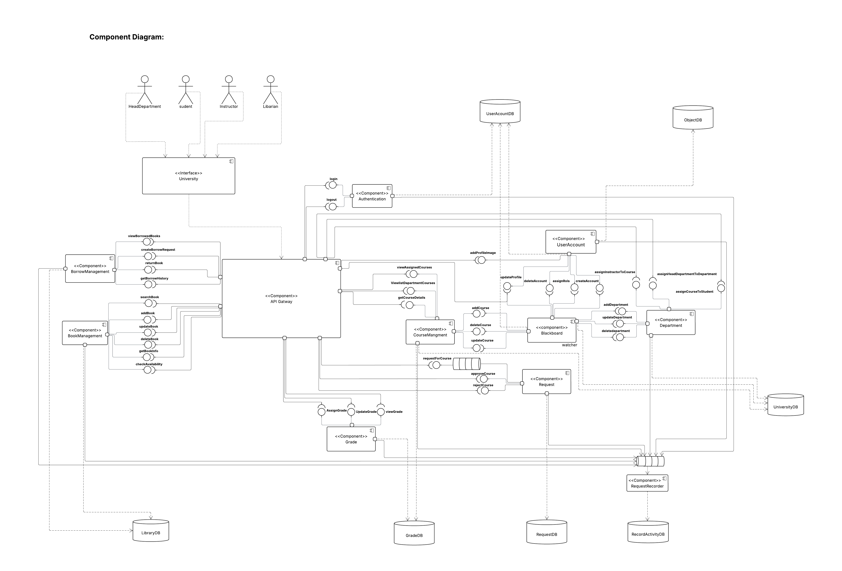

3. Non-Functional Requirements

3.1 Scalability
• NFR-S1: The system should support 200 concurrent users during peak times and 5,000 total registered users.
• How We Achieved It:
We deployed 3 replicated servers and used cloud-based infrastructure with auto-scaling to accommodate increasing traffic and growing user base.

3.2 Performance
• NFR-P1: The system should respond to 95% of requests within 2 seconds under normal load.
• How We Achieved It:
We implemented load balancing, IP Hashing, and sharded databases to optimize response times and ensure efficient data handling.

3.3 Availability
• NFR-A1: The system should provide 99.9% uptime during peak periods.
• How We Achieved It:
We used redundant load balancers, replicated servers, and sharded databases to ensure high availability and automatic failover. To prevent any single point of failure and ensure consistent service, we implemented health checks between the load balancers. These health checks monitor the system’s health and automatically reroute traffic to healthy components if a failure is detected, ensuring continuous uptime and minimizing service disruptions.

4. Architectural Diagram and Description

Architectural Diagram:
Figure 2Below is the architecture diagram representing the overall system architecture, including its layers, core components, and their interactions.

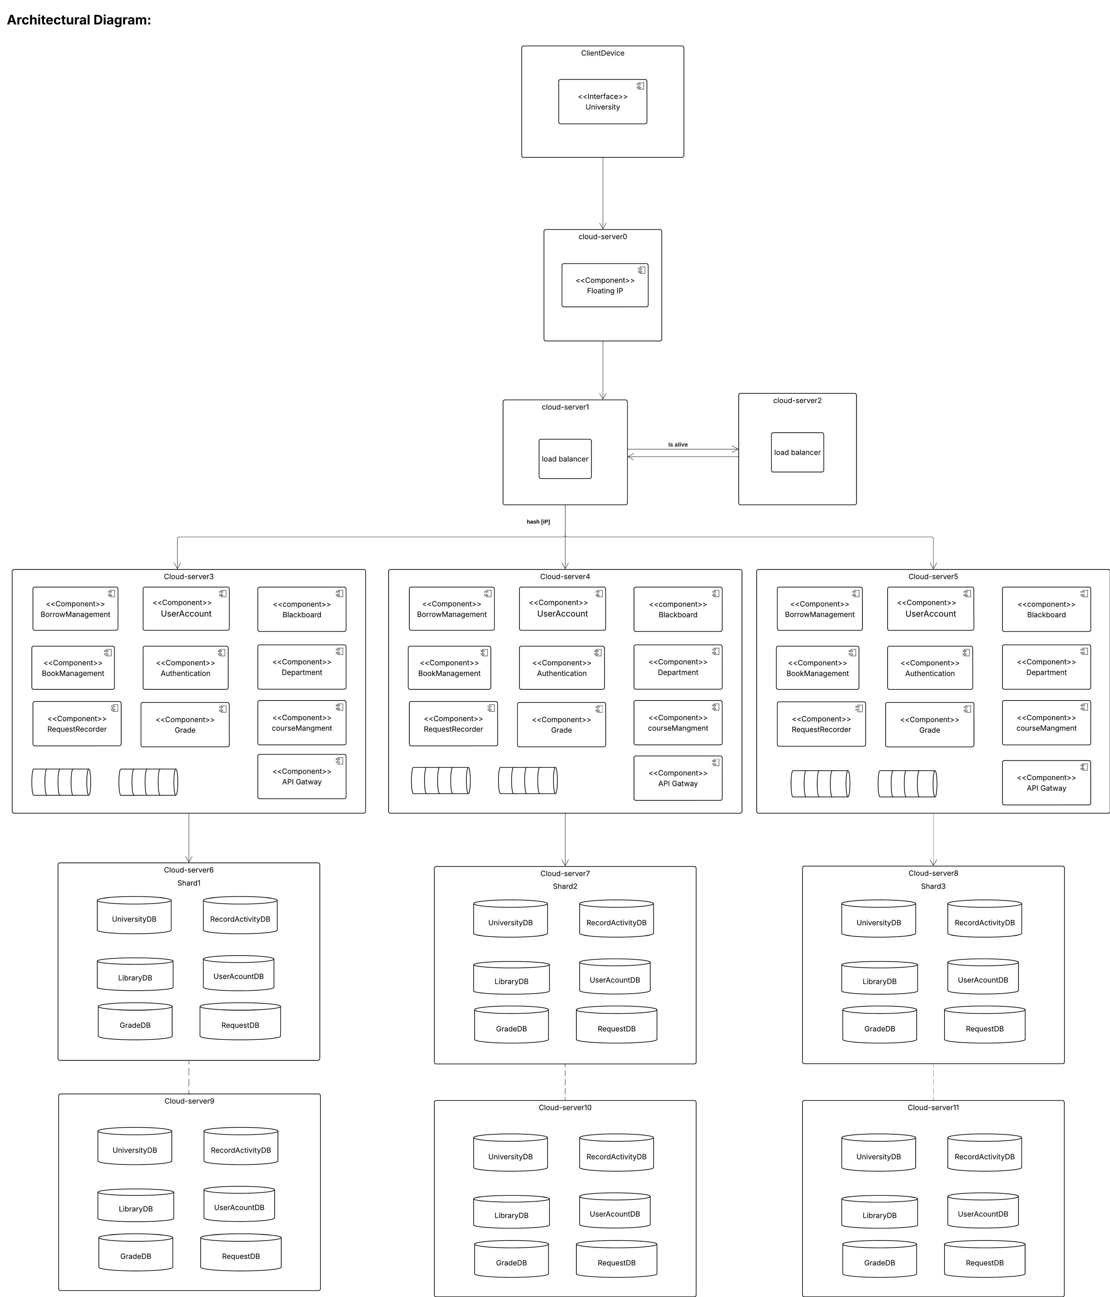

Description of Architecture:
The University & Library Hub System is designed using a Client-Server architecture to ensure integrated availability, scalability, and high performance. The system includes the following components:
1. API Gateway: This serves as the primary access point for students, instructors, department heads, and librarians to interact with the system through a unified interface. Requests are then router to the appropriate backend components.
2. Load Balancer: Two Load Balancers are used to distribute traffic efficiently, ensuring high availability and optimal performance. Health Checks are performed between the load balancers, and IP Hashing directs the traffic across 3 replicated servers, ensuring load balancing and redundancy for comprehensive availability.
3. Replicated Servers: The system uses 3 replicated servers that host the core components of the system. These servers handle various requests, ensuring scalability and fault tolerance as demand grows.
4. Sharded Databases: Data is partitioned into shards and distributed across the system. Requests are directed by the Load Balancer and IP Hashing to the appropriate sharded databases, ensuring high performance and scalability when handling large amounts of data.

